QUILF Basics

Fill in your weight percent for OPX
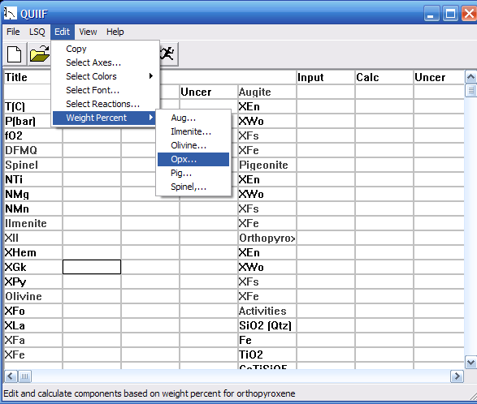

Then click “Formula” button, then click “OK” button
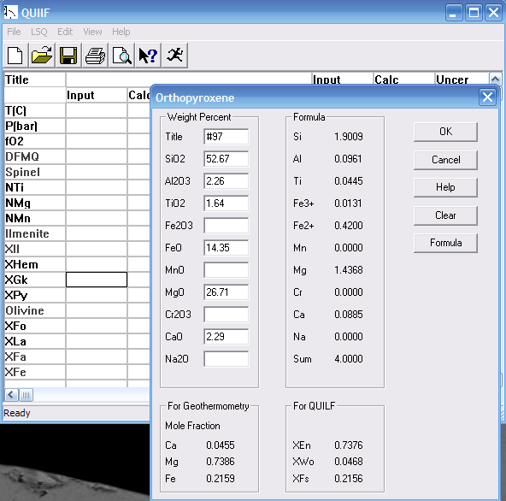

Next, your OPX values will be automatically transferred to the QUILF page in the “Input” column. Then enter your run temperature (°C and limited between 400 and 1500) and pressure (bars and limited between 1 and 32767) in the “Input” column. Then in the “Input column” enter some (any) fractional number in the “XGk box” followed by a “?”, which signifies to the program the parameter you want it to calculate. (the “XGk box” represents the mol fraction of geikielite in ilmenite). Now you are ready to run the calculation.
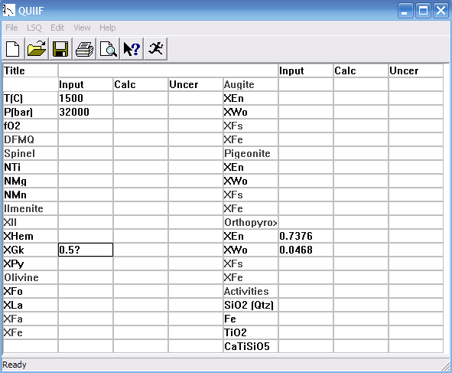
To run the program click on the run button “”. Then values will appear in the “Calc” column. These values represent the equilibrium values for the conditions specified (i.e., the XIl and XGk should equal those of your experiment if P, T, and OPX composition are all correct (notice that these values did not change between the “Input” column and the “Calc” column.
